***Homework N1 Due Thursday February 4th before class***

***Question 1.***

*Download the data file davis.csv*

*Davis data shows self-reports of Height and Weight.*

*Data Set Description:*

*The Davis data frame has 200 rows and 5 columns. The subjects were men and women engaged in regular exercise. There are some missing data.*

*Format*

*This data frame contains the following columns:*

*Sex ( F, female; M, male.)*

*Weight (Measured weight in kg.)*

*Height (Measured height in cm.)*

*Repwt (Reported weight in kg.)*

*Rrepht (Reported height in cm.)*

*Source: Personal communication from C. Davis, Departments of Physical Education and Psychology, York University.*

1. ***Identify the data type for each variable***
2. ***Specify which methods will be applicable to describe these variables based on data type?***
3. ***Using R describe variable weight, height and sex***

***Question 2***

*Calculate conditional probabilities for the hypertension example from lecture 2*

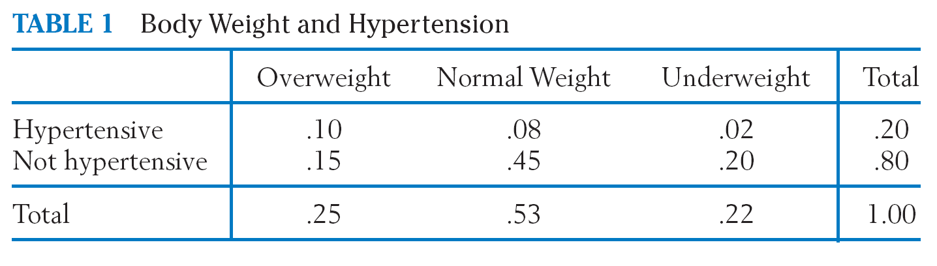

1. ***A randomly-selected person is normal weight. What is the probability that the person also has hypertension?***
2. ***A randomly-selected person hypertensive. What is the probability that the person also overweight?***
3. ***A randomly-selected person hypertensive. What is the probability that the person has normal weight?***

***Question 3***

Suppose we are given three boxes, Box A contains 10 light bulbs, of which 4 are

defective, Box B contains 6 light bulbs, of which 1 is defective and Box C contains 8

light bulbs, of which 3 are defective. We select a box at random and then draw a light

bulb from that box at random. What is the probability that the bulb is defective?

Here we are performing two experiments:

a) Selecting a box at random

b) Selecting a bulb at random from the chosen box

If A, B and C denote the events choosing box A, B, or C respectively and D and N

denote the events defective/non-defective bulb chosen, then:

1. ***Construct a diagram with probabilities that represent two experiments***
2. ***Find the probability of selecting box A and then getting a defective bulb***
3. ***Find the probability of selecting defective bulb***

***Question 4***

The probability that a new small firm will survive for 2 years has been estimated at 0.22. Given that it survives for 2 years, the probability that it will have a turnover in excess of $250,000 per year in a further 3 years is estimated at 0.44. Determine the probability that a new business starting now will have a turnover of more than $250,000 in 5 years